**EXPERIMENT 5**

Demonstrate virtualization by Installing Type-2 Hypervisor in your device, create and configure VM image with a Host Operating system (Either Windows/Linux).

1.open VM ware and click on create

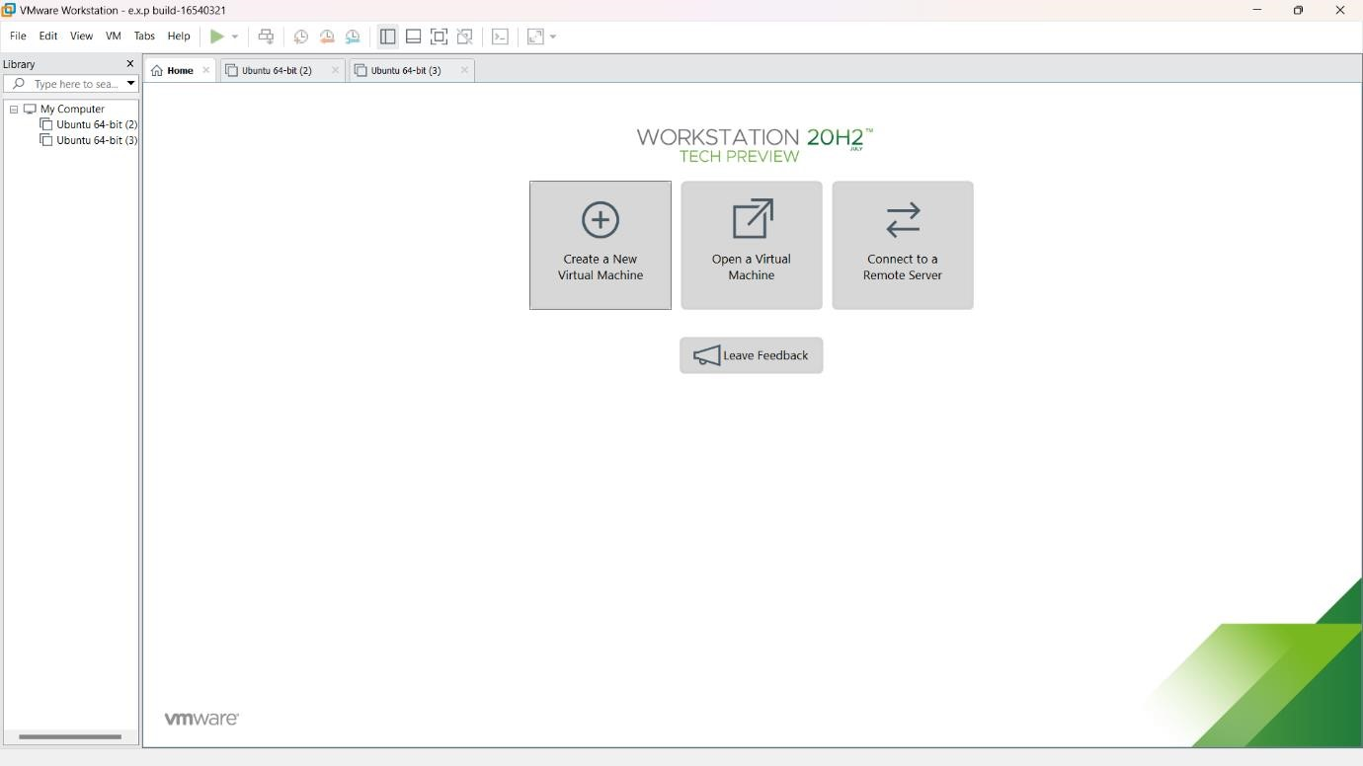

# 2.click on next

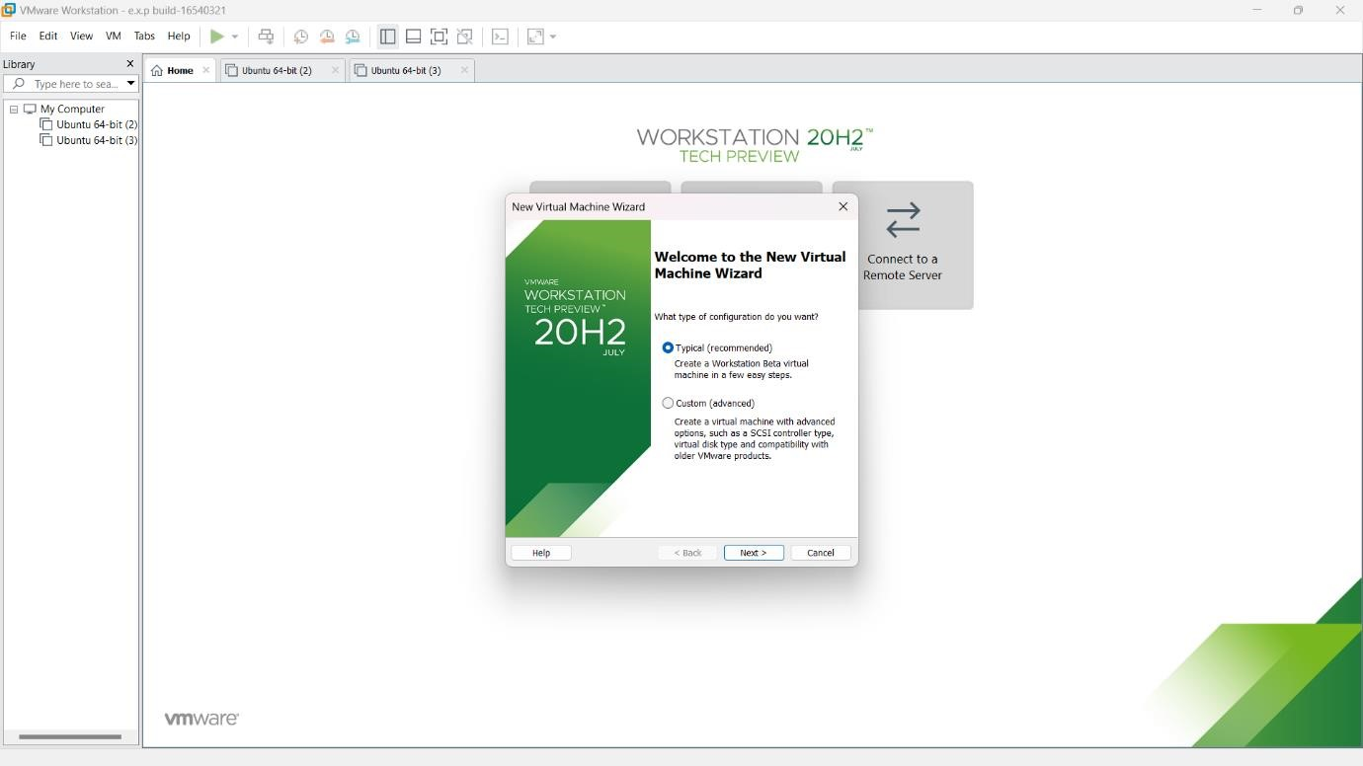

# 3.select browser and choose your software file and click on next

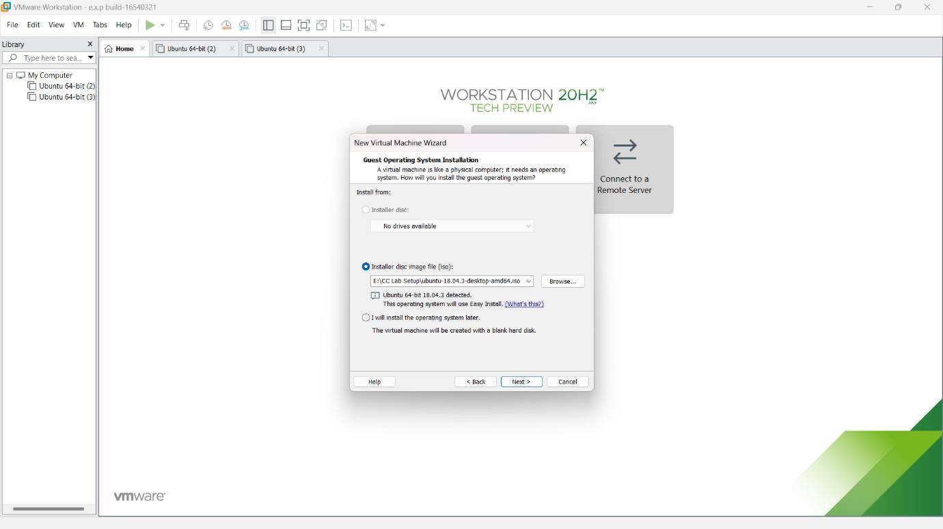

# 4.enter required details

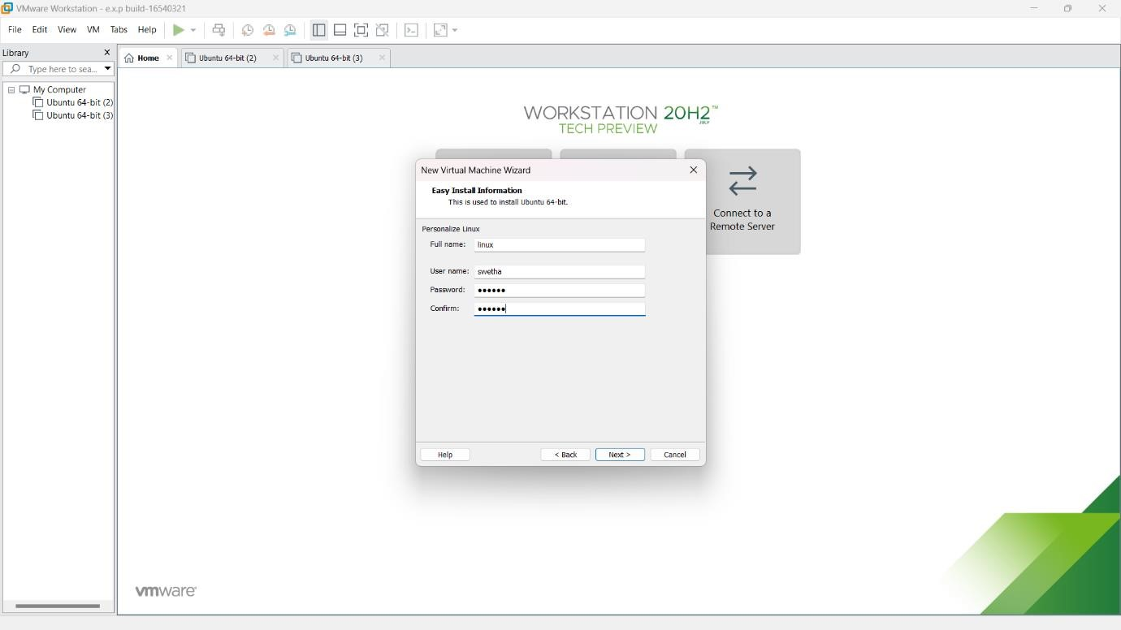

# 5.click on next

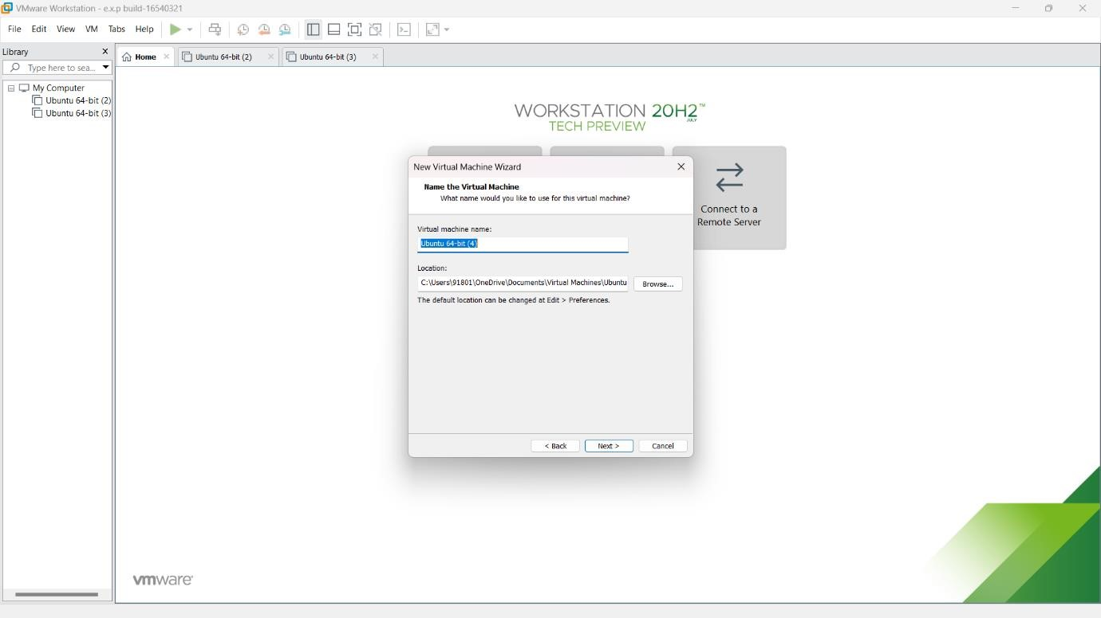

# 6.select store in single file

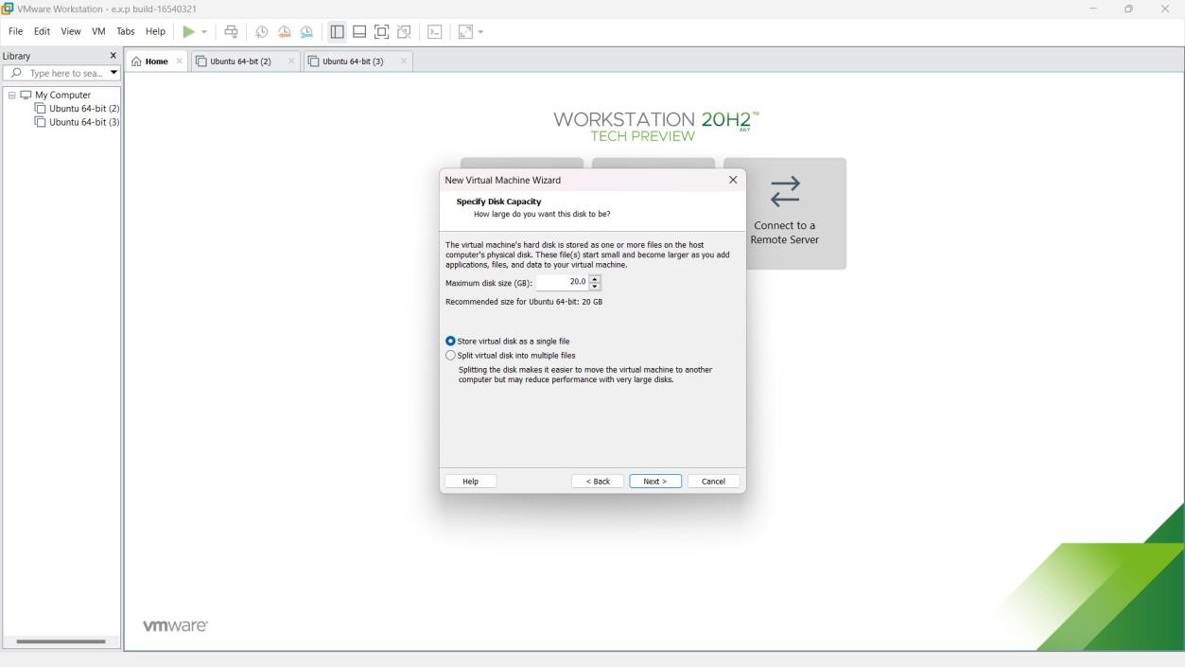

# 7.check details and click next

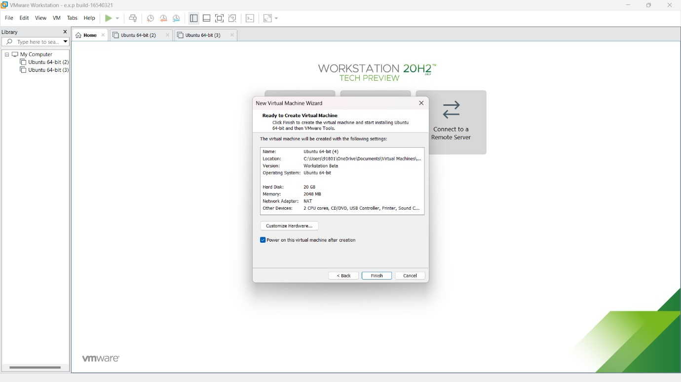

# 8.obtaining VM waree

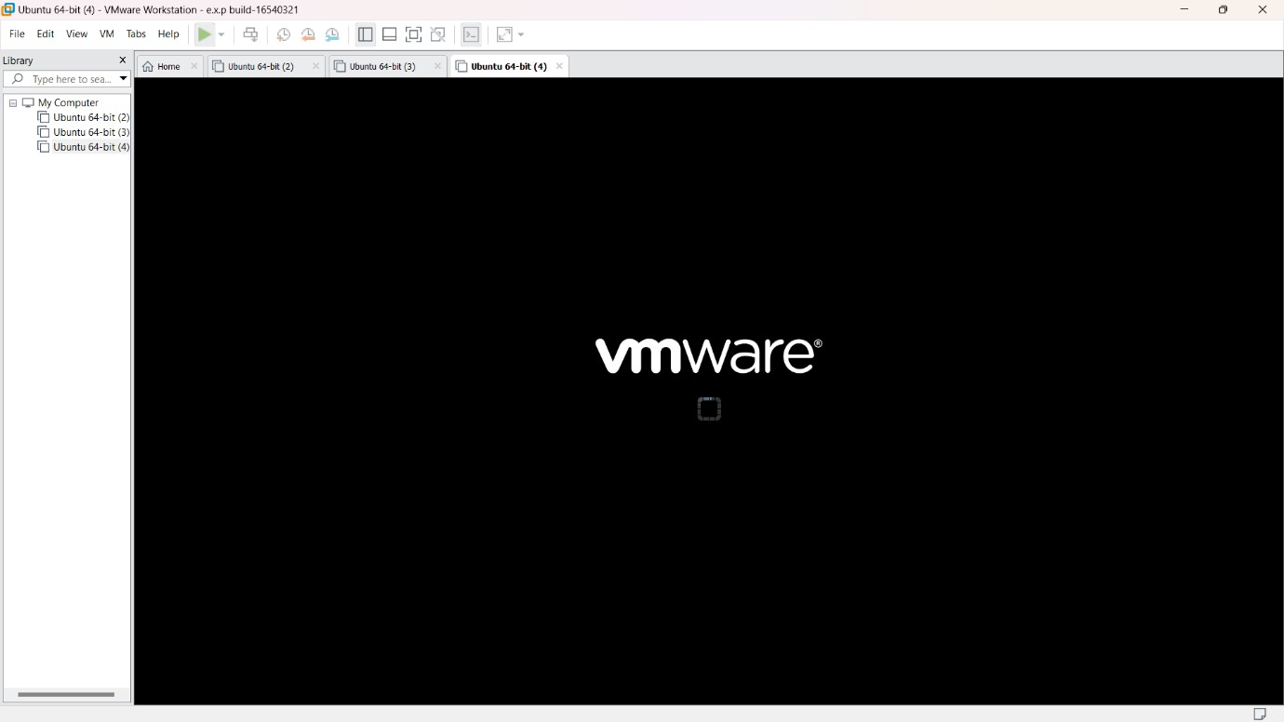

# what password you entered in step 4 enter the same here and then login

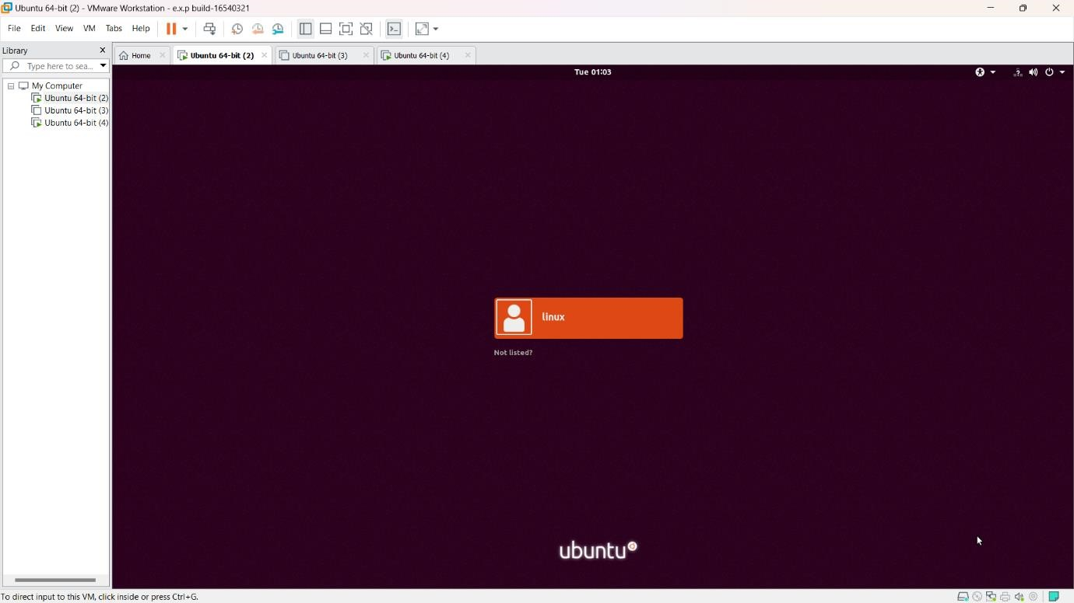

10. finally VM image with a Host Operating system is obtained

